**One man spent the last 40 years planting 1 tree every day… he is the Forest Man**

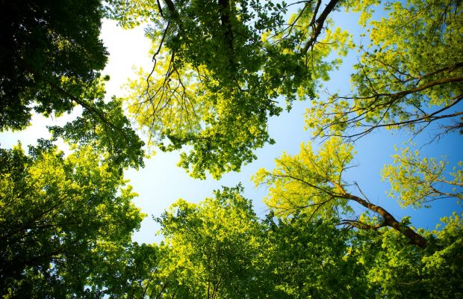

**India’s Forest Man started planting trees on the worlds largest river island in 1979. Today it’s even bigger than Central Park!**

In 1979 a man by the name of Jadav Payeng started planting trees in a wasteland. He went to this area every single day and planted a new tree. Now over 40 years later, he has planted something so spectacular they created a small documentary about him.

The forest he planted is now bigger than New York City’s Central Park. When Jadav started out, he planted a few seeds on a barren space and now the forest is over 500 hectares, 3 months out of the year it is home to elephants and now boasts a population of Indian rhino as well as tigers. See more